EUIPO’s workshop on IP tools in Cameroon

A Technical Workshop on Tools was held at the headquarters of the Organisation Africaine de la Propiété Intellectuelle

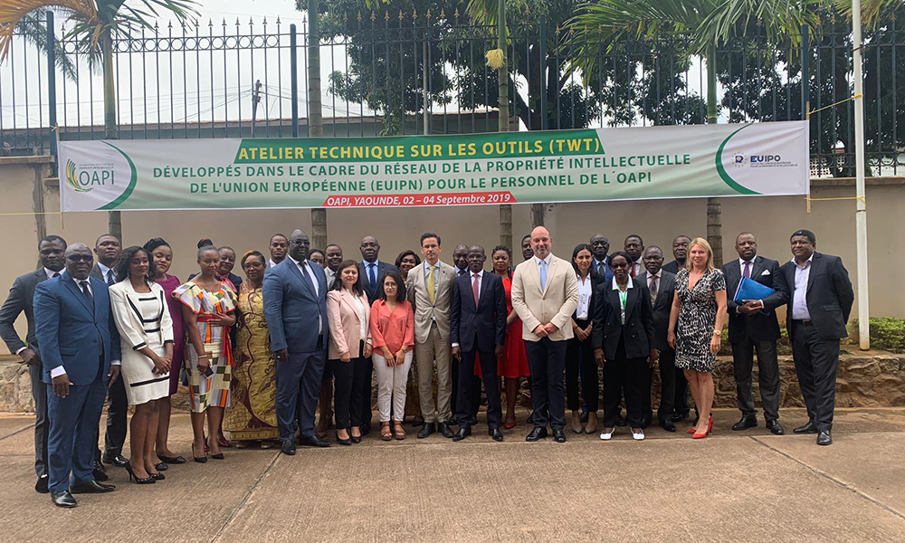

A Technical Workshop on Tools was held at the headquarters of the Organisation Africaine de la Propiété Intellectuelle (OAPI) in Yaoundé, Cameroon on 2-4 September 2019.

The workshop, organised under the framework of the EUIPO’s [international cooperation activities](https://euipo.europa.eu/ohimportal/en/international-cooperation), facilitated a multilateral and collaborative cooperation, allowing the exchange of information and experiences between the OAPI and EUIPO. Both offices focused on **extending the benefits of the tools developed under the European Union Intellectual Property Network (EUIPN), in particular TMview.**

During the workshop, a consultation process with the OAPI was also organised in order to identify **specific joint actions for the upcoming EU-funded Pan-African project** in the field of Intellectual Property Rights, which will be implemented by the EUIPO.

The EUIPO’s 2020 vision is to deliver high-quality products and services to trade mark and design users, which requires expanding its focus to the international arena, in the framework of the Strategic Plan 2020 (SP2020). In particular, Line of Action 4 of the SP2020 includes the Office’s strategy to extend the benefits of the tools and practices developed by the EUIPN beyond the borders of the EU for the benefit of users.

As part of this strategy, since 2017, EUIPO has hosted various technical workshops with non-EU IP offices in Latin America, Africa, Asia and Oceania, thus increasing the outreach of the Network’s tools and practices globally.